## **Background and Primitive Datatype Workshop**

**Work through the below tasks to practice what has been covered in today’s workshop. Rather than focusing on getting the correct answer, it’s the process of getting to the answer that’s important; ask for help but do not copy others, it’s more important to think about these tasks then getting the answers right.**

**Task 1**

Use “Get-Help” to find out more information about 5 cmdlets not covered in today’s workshop.

*As an example you can use “Get-Service” or “Out-GridView”*

Notes:

Get-Help Get-Help

Get-Help New-Item

Get-Help Get-Alias

Get-Help Get-AuthenticodeSignature

Get-Help Get-ControlPanelItem

# Although any 5 cmdlets will do

**Task 2**

Use “Get-Help” with the “–Example” parameter for the 5 cmdlets you discovered more about in task 1.

Notes:

Get-Help Get-Help -Examples

Get-Help New-Item -Examples

Get-Help Get-Alias -Examples

Get-Help Get-AuthenticodeSignature -Examples

Get-Help Get-ControlPanelItem -Examples

# Although any 5 cmdlets will do

**Task 3**

Create a new text file named “TestFile.txt” under C:\Sudoblark\PowerShell\Workshop1\%USERNAME%

*The cmdlet to make a file and a new directory starts with “New”*

Notes:

New-Item -Path C:\ -Name Expo -ItemType Directory

New-Item -Path C:\Sudoblark -Name PowerShell -ItemType Directory

New-Item -Path C:\Sudoblark\PowerShell -Name Workshop1 -ItemType Directory

New-Item -Path C:\Sudoblark\PowerShell\Workshop1 -Name bclark -ItemType Directory

New-Item -Path C:\Sudoblark\PowerShell\Workshop1\bclark\ -Name Testfile.txt -ItemType File

**Task 4**

Populate the text file you created in task 3 with all three datatypes we’ve covered: “Boolean”, “String” and “Int”

*The cmdlet you need starts with “Add”*

Notes:

Add-Content -Path C:\Sudoblark\PowerShell\Workshop1\bclark\Testfile.txt -Value True

Add-Content -Path C:\Sudoblark\PowerShell\Workshop1\bclark\Testfile.txt -Value "Hello"

Add-Content -Path C:\Sudoblark\PowerShell\Workshop1\bclark\Testfile.txt -Value 42

**Task 5**

Read from the text file and use “Get-Member” to find the datatype returned

*The cmdlet you need to read data from the text file begins to “Get”*

Notes:

Get-Content -Path C:\Sudoblark\PowerShell\Workshop1\bclark\Testfile.txt | Get-Member

**Task 6**

Overwrite all data within the text file that you created in task 3.

*The cmdlet you need starts with “Set”*

Notes:

Set-Content -Path C:\Sudoblark\PowerShell\Workshop1\bclark\Testfile.txt -Value "Boooooo"

**Task 7**

Format the data returned by a cmdlet into a list

*You will need to pipe the original cmdlet then use the “Format-List” cmdlet*

Notes:

Get-Service | Format-List

**Task 8**

Pipe “Get-Command” into “Out-GridView”

Notes:

Get-Command | Out-GridView

**Task 9**

Pipe the 5 cmdlets you discovered in task 1 into “Out-GridView”

Notes:

Get-Help | Out-GridView

New-Item | Out-GridView

Get-Alias | Out-GridView

Get-AuthenticodeSignature | Out-GridView

Get-ControlPanelItem | Out-GridView

**Task 10**

Find the official PowerShell documentation library from Microsoft

*Google MSDN PowerShell. The URL starts with “https://docs.microsoft.com”*

Notes:

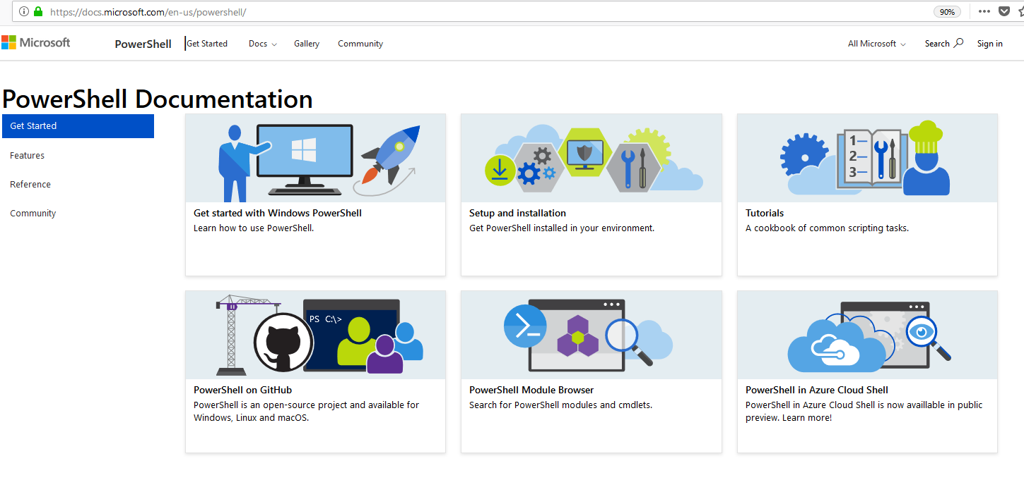

**Task 11**

Find the webpage on the official PowerShell documentation that explains information about the “Get-Help” cmdlet

Notes:

